***Annexure-“G”***

**Few Basics of electrical engineering**

1. **General formulas**:
2. OHM’s Law : **V = I*R, :**

Whereas:

**V=**System Voltage,

**I=**Current flowing in the conductor in Amps.

**R=** Resistance of conductor in Ohms (Ω).

1. Power consumption by the load in Watts for D.C =**V*I.**
2. Power consumption by the load in Watts for S-Ph A.C =**V*I* Cos ¢**
3. Power consumption in 3-Ph A.C System in Watts = **√3 * V*I*Cos ¢**

**V= Phase to Phase Voltage,**

**I = Phase current in Amps,**

**Cos ¢ = Power factor**

1. Energy in watt hours **= Watts * number of Hrs**
2. **Energy in kWh (Units) = Watt Hrs / 1000**
3. **Power loss in the conductors:**
4. The conductor offers resistance to flow of current in the circuit and some portion of the electrical **Energy** /**Power** is lost in the process in form of heat generation in the conductor of Circuit / Line/ Cable /Transformer.
5. The quantum of power (Watts) loss in the conductor is proportional to square of the current (Amps) flowing in the conductor of a circuit and resistance (Ω ) offered by the conductor of the circuit
6. **Voltage drop in the conductors**
7. The impedance “**Z”** offered by the conductors of 3 - Ph A.C. system will cause the voltage drop and hence the receiving end voltage will be less than sending end voltage.
8. The quantum of voltage drop in the conductor is product of current (Amps) flowing in the circuit and resistance of the conductor (Ω).
9. The resistance of the conductor is proportional to conductor material (Aluminum, Alloyed Aluminum, Copper etc) , its length and sectional area which is represented by formulae **ρ L/a,**
10. Whereas **ρ** = constant for conductor material, **L** = length of the conductor and **a =** cross sectional area of the conductor.
11. ***Hence selection of the conductor by its material, cross sectional area will play major role for power system design to minimize the system power loss and system voltage drop***
12. Power loss in a conductor **Watts = (V *I*) = I²*R. (since V=I*R)**

**I**=Current flowing in the conductor and **R** is resistance of the conductor in Ω (Ohms)

1. Power loss in 3 conductors of 3-Phases in A.C system in Watts  **= 3* I²*R.**
2. % Voltage regulation **= { (Vs-Vr) * 100 } /Vs**

Whereas **Vs =** Sending end voltage**, Vr =** Receiving end voltage

1. **Load factor (L.F.):**

Average load / Peak load

**OR**

(Energy served) / (Peak load x Number of Hrs during the period)

1. **Loss Load Factor (L.L.F)**

**(Average power loss) / (Power loss at peak load**).

An empirical formula to relate the **loss load Factor** *(L.L.F)* **= A x LF+ (1-A) x LF².**

A is factor, which is either **0.2** or **0.3** depending on the system networks

LLF = 0.2 LF +0.8 LF**²**. **OR** 0.3 LF +0.7 LF**².**

The generally adopted formulae For Karnataka:

**Transmission system:LLF = 0.2 LF +0.8 LF²**

**Distribution system: LLF= 0.3*LF + 0.7 LF²**

1. **Impedance “Z” = √ { (R) ² + (Xl / Xc)²}**

Whereas:

Z = Impedance.

Xl = Inductance (Both Self &Mutual inductance).

Xc = Capacitance

1. Voltage drop = **I * Z**
2. The Xl & Xc values are almost negligible compared to Resistance in A.C. Primary & Secondary distribution system of 11 kV voltage and below. Hence for analytical calculation of voltage drop only Resistance value is considered in 11 kV & L.T.lines.
3. The Xl & Xc values are predominant and higher compared to Resistance in HV & EHV system of 33 kV and above, hence impedance (Z) values are considered in A.C 33 kV and above voltage system.

***Annexure –“H”***

***Computation / Assessment of Energy Loss and % V.R by Soft ware***

1. **Data requirement:**

The following month wise details of the 11 kV feeders and DTC are to be collected from substation and ETV meters of DTCs**.**

| **Sl No** | **Month & Year** | **Monthly Energy sent out in kWhr** | **Peak load in Amps** | **Power Factor during the peak** | **Number of Hrs the feeder/DTC was in service** | **Monthly load factor** |
| --- | --- | --- | --- | --- | --- | --- |
| 1 |  |  |  |  |  |  |
| 2 |  |  |  |  |  |  |
| 3 |  |  |  |  |  |  |
| 4 |  |  |  |  |  |  |
| 5 |  |  |  |  |  |  |
| 6 |  |  |  |  |  |  |
| 7 |  |  |  |  |  |  |
| 8 |  |  |  |  |  |  |
| 9 |  |  |  |  |  |  |
| 10 |  |  |  |  |  |  |
| 11 |  |  |  |  |  |  |
| 12 |  |  |  |  |  |  |
| **Total** | |  |  |  |  |  |

1. **Assessment of Peak power Losses, Annual Energy losses & % V.R by Distribution analysis soft ware.**
2. Load Flow Analysis is one of the most common computational procedures used in power system analysis and planning. The distribution system comprising 11 kV line & L.T 400 volts is generally radially operated. Hence 11 kV feeder wise load flow analysis to be conducted for assessing the peak power losses and tail end voltages.
3. The conducting of load flow studies using distribution system soft ware will be Faster, Accurate and Facilitates examination of various alternates for improvement of the system and facilitates easy selection of least cost, best alternate for implementation.
4. The conductors used in the 11 kV lines in Karnataka are “Coyote”, “Rabbit”, “Weasel” and “Squirrel” ACSR. Positive sequence parameters of the 11 kV line furnished in the following table with standard line configuration, generally practiced in the country to be used for conducting load flow studies.

|  |  |  |  |  |  |
| --- | --- | --- | --- | --- | --- |
| **11 kV line parameters** | | | | | |
| **Sl. No** | **ACSR Conductor type** | **R (ohm/km)** | **X (ohm/km)** | **Current rating (A)** | **MVA rating** |
| 1 | Squirrel | 1.394 | 0.386 | 97 | 1.848 |
| 2 | Weasel | 0.9291 | 0.374 | 123 | 2.343 |
| 3 | Rabbit | 0.5524 | 0.369 | 190 | 3.62 |
| 4 | Coyote | 0.266 | 0.35 | 292 | 5.56 |

1. Stimulation of the 11 kV feeder wise net work data with sectional lengths, conductor sizes, peak load recorded during the year, capacity of DTCs, PF of the feeder during the peak load time for the 11 kV in the soft ware.
2. Similarly Stimulation of the DTC wise L.T. System net work data of with sectional lengths, conductor sizes, peak load & PF recorded at DTC, and assessed /computed connected load of each I.P sets for LT Line catered from each DTC in software.
3. The soft ware output will directly furnish the Peak power losses in KW, and bus wise voltage the system. The least bus voltage value to be used for computing % V.R
4. Peak Power Loss in KW will be the output from soft ware.
5. Annual energy losses in kWh will be:

= Peak power losses (KW) * LLF * Number of hrs (T) during the year the 11 kV feeder or DTC was in service.

1. % V.R ( Voltage regulation) = **= { (Vs-Vr) * 100 } / Vs**
   1. **Load flow studies for a typical 11 kV line:**
2. The load flow studies have been conducted using Mi-power soft ware for a typical 11 kV feeder as shown in the following SLD for both Rabbit ACSR conductor and Squirrel ACSR conductor of the 11 kV line.

file-page1.png

1. The load flow study results of peak power losses , annual energy losses and % voltage regulation for both Rabbit ACSR and Squirrel ACSR conductors are shown in the Table:

|  |  |  |  |
| --- | --- | --- | --- |
| **Load flow study for 11kV feeder** | | | |
| Sl No | Particulars | **using Rabbit ACSR conductor** | **using Squirrel ACSR conductor** |
| 1 | Total connected transformer capacity in KVA | 1000 | 1000 |
| 2 | Total line length of the feeder in km (as per diagram) | 10.1 | 10.1 |
| 3 | Peak load in A | **40** | **40** |
| 4 | Load Power Factor | 0.8 | 0.8 |
| 5 | TOTAL REAL POWER GENERATION in kW | 611.53 | 613.99 |
| 6 | TOTAL REACT. POWER GENERATION in kVAR | 457.34 | 451.53 |
| 7 | TOTAL REAL POWER LOAD in kW | 604.00 | 596.00 |
| 8 | TOTAL REACTIVE POWER LOAD in kW | 453.00 | 447.00 |
| 9 | TOTAL REAL POWER LOSS in kW | 7.53 | 17.98 |
| 10 | PERCENTAGE REAL LOSS in kW | 1.23 | 2.93 |
| 11 | TOTAL REACTIVE POWER LOSS in kVHR | 4.33 | 4.53 |
| 12 | Tail end voltage in kV | 10.84 | 10.68 |
| 13 | % Voltage regulation | 1.47% | 2.93% |
| 14 | Annual Energy input to the feeder in kWh | 2136000 | 2136000 |
| 15 | Load factor | 0.40 | 0.40 |
| 16 | Loss Load factor | 0.232 | 0.232 |
| 17 | Annual Energy loss in kWh | 15309 | 36534 |
| 18 | **% Annual Energy loss** | **0.72%** | **1.71%** |

2.2. Load **flow study for a typical L.T.Line:**

a) The load flow studies have been conducted using Mi-power soft ware for a typical a typical L.T. distribution system catered from a 100 KVA DTC as shown in the following SLD for both Rabbit ACSR conductor and Weasel ACSR conductor of the L.T. 3-P, 4- wire L.T. line:

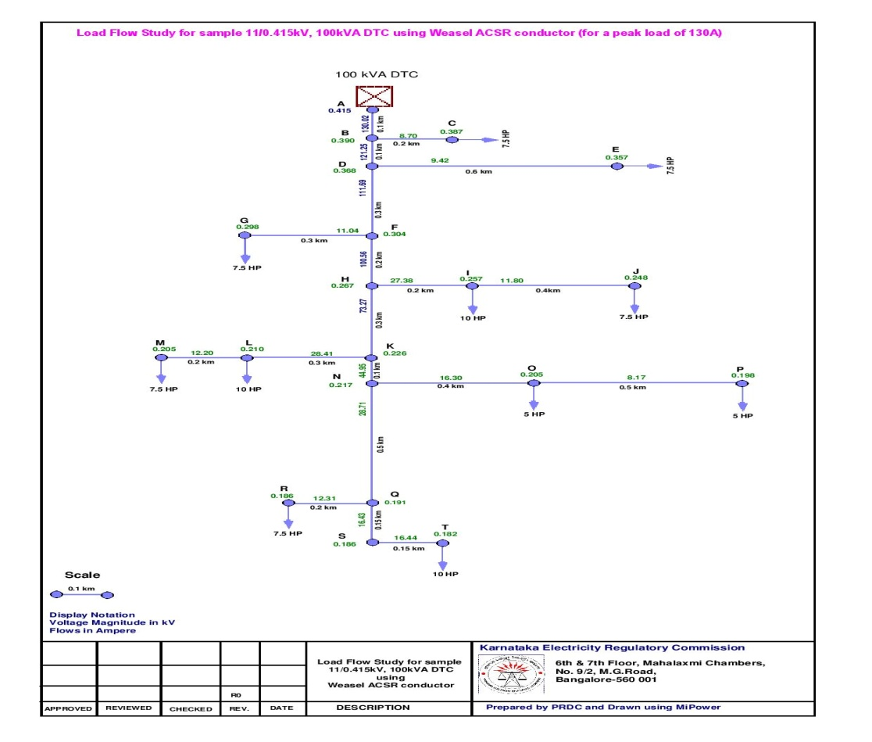

1. The load flow study results of peak power losses , annual energy losses and % voltage regulation for both Rabbit ACSR and Weasel ACSR conductors are shown in the Table:

|  |  |  |  |
| --- | --- | --- | --- |
| **Load flow study for LT Distribution system from a 100 KVA DTC** | | | |
| Sl No | Particulars | **using Rabbit ACSR conductor** | **using Weasel ACSR conductor** |
| Load flow study for peak load | Load flow study for peak load |
| 1 | Total connected load in kW / HP | 63.4 / 85 | 63.4 /85 |
| 2 | Total line length of the LT Distribution transformer in km | 5.2 | 5.2 |
| 3 | Peak load in A | **130.00** | **130.00** |
| 4 | Load Power Factor | 0.8 | 0.8 |
| 5 | TOTAL REAL POWER GENERATION in kW | 76.40 | 81.09 |
| 6 | TOTAL REACT. POWER GENERATION in kVAR | 53.92 | 46.45 |
| 7 | TOTAL REAL POWER LOAD in kW | 54.24 | 43.60 |
| 8 | TOTAL REACTIVE POWER LOAD in kW | 40.71 | 32.73 |
| 9 | TOTAL REAL POWER LOSS in kW | 22.16 | 37.49 |
| 10 | PERCENTAGE REAL LOSS in kW | 29.01 | 46.23 |
| 11 | TOTAL REACTIVE POWER LOSS in kVAR | 13.21 | 13.73 |
| 12 | Tail end voltage in kV | 0.261 | 0.182 |
| 13 | % Voltage regulation | 37.22% | 56.24% |
| 14 | Annual Energy input to the DTC in kWhr | 250000 | 250000 |
| 15 | Load factor | 0.4 | 0.4 |
| 16 | Loss Load factor | 0.232 | 0.232 |
| 17 | Annual Energy loss | 55200 | 93386 |
| 18 | **% Annual Energy loss** | **18.01%** | **30.48%** |

**Note:**

The (Single Line Diagram) SLDs were prepared and Load flow studies were conducted using Mi-Power soft ware. It may be noted that any distribution system analysis soft ware other than Mi-Power can also be used by the ESCOMs for computation of Technical loss and percentage voltage regulation.

***Annexure-“I”***

1. **Assessment of Annual Energy losses & % V.R by KVA* KM Method**

The KVA*KM method as per the empirical formulae developed by REC and furnished to Utilities during the year 1970 and a simple soft ware was also developed by Utilities in Karnataka.

|  |  |  |  |
| --- | --- | --- | --- |
| **Computation of Annual Energy losses - KVA*KM Method** | | | |
| **Sl No** | **Particulars** | **Unit** | **Formulae** |
| **1** | **Annual Energy losses** | **kWh** | **(0.105*L*R*P² * LLF) / ( 2*LDF*DF² )** |
| a) | DF. --- Diversity Factor |  | (Connected Load) / (Peak Load) |
| b) | LLF --- Loss Load Factor |  | 0.3 * LF + 0.7 * LF*LF |
| c) | LDF. --- Load Distribution Factor |  | **(P*L) / (KVA*KM)** |
| d) | P = Connected Load in kVA. |  |  |
| e) | L = Length of the Line in kM |  |  |
| f) | R = Resistance of the conductor per KM in ohms. |  |  |
| **2** | **Voltage Regulation** |  | **1.06*P*L*PF / LDF*RC* DF** |
| a) | PF = Power Factor. |  |  |
| b) | RC = Regulation Constant for conductors |  |  |
| i | **Squirrel – 771** |  |  |
| ii | **Weasel – 1043** |  |  |
| iii | **Rabbit -- 1524** |  |  |

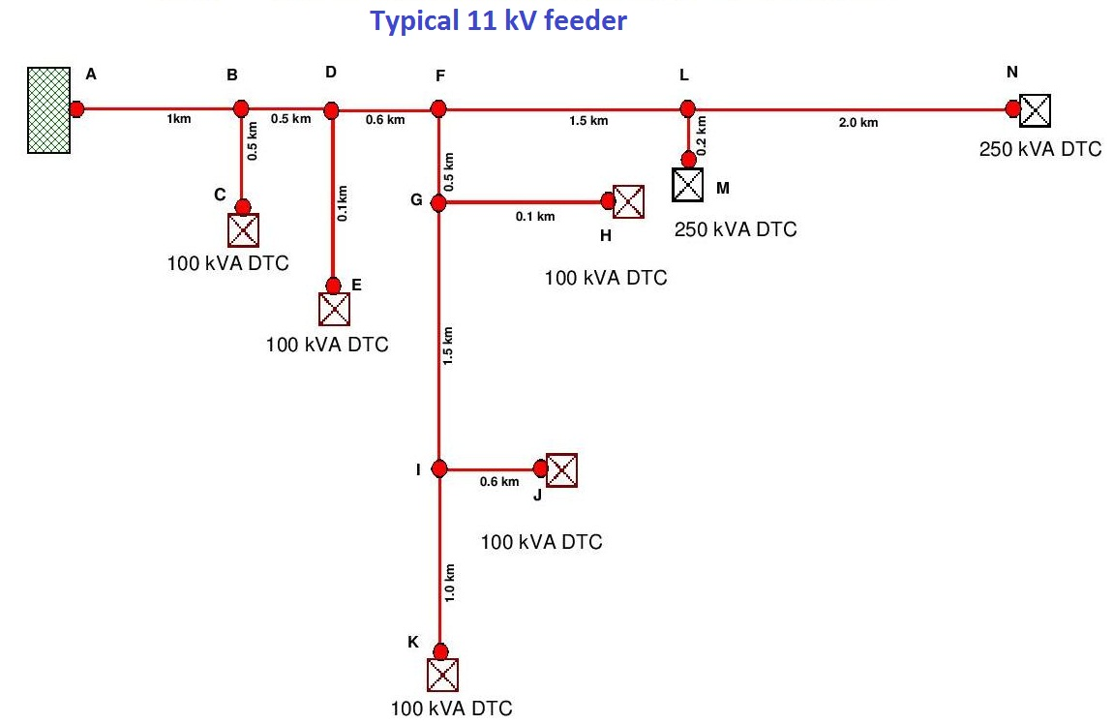

* 1. **KVA * KM computation:**

|  |  |  |  |  |
| --- | --- | --- | --- | --- |
| **KVA * KM Computation** | | | | |
| **Sl No** | **Section** | **Capacity in KVA** | **Length in Kms** | **KVA*KM** |
| **1** | N-L | **250** | **2.0** | **500.0** |
| **2** | M-L | **250** | **0.2** | **50.0** |
| **3** | L-F | **500** | **1.5** | **750.0** |
| **4** | K-I | **100** | **1.0** | **100.0** |
| **5** | J-I | **100** | **0.6** | **60.0** |
| **6** | I-G | **200** | **1.5** | **300.0** |
| **7** | H-G | **100** | **0.1** | **10.0** |
| **8** | G-F | **300** | **0.5** | **150.0** |
| **9** | F-D | **800** | **0.6** | **480.0** |
| **10** | E-D | **100** | **0.1** | **10.0** |
| **11** | D-B | **900** | **0.5** | **450.0** |
| **12** | C-B | **100** | **0.5** | **50.0** |
| **13** | B-A | **1000** | **1.0** | **1000.0** |
| **14** | **Total KVA*KM** | | | **3910.0** |

* 1. **Annual Energy loss computation of 11 kV typical feeder by KVA*KM Method:**

|  |  |  |  |
| --- | --- | --- | --- |
| **Energy loss calculations by KVA * KM analytical method** | | | |
| **Sl No** | **Particulars** | **Values** | |
| 2 | Feeder Name | Typical 11 kV feeder | |
| 3 | Peak load in Amps | 40 | |
| 4 | P.F | 0.8 | |
| 5 | Peak load in KVA | 762 | |
| 6 | Peak load in kW | 610 | |
| 7 | Annual energy in kWh | 2136000 | |
| 8 | Length of the feeder in km | 10.1 | 10.1 |
| 9 | Size of the conductor | Rabbit ACSR | Squirrel ACSR |
| 10 | Resistance of the conductor per km | 0.5524 | 1.394 |
| 11 | KVA * KM | 3910 | 3910 |
| 12 | Annual Load Factor (L.F.) | **0.40** | **0.40** |
| 13 | Loss Load Factor (L.L.F.) | **0.232** | **0.232** |
| 14 | Connected capacity of DTCs in KVA | **1000** | **1000** |
| 15 | Diversity Factor ( D.F) | **1.31** | **1.31** |
| 16 | Load distribution factor (L.D.F.)= (P*L) / KVA * KM | **2.58** | **2.58** |
| 17 | Annual energy losses in kWh | **15276** | **38549** |
| (0.105*L*R*P*P*LLF) |  |  |
| ( 2*LDF*DF ²) |  |  |
| 18 | Annual Energy loss in MU | 0.015 | 0.039 |
| 19 | % Energy Losses | **0.72%** | **1.80%** |

* 1. **Computation of Voltage regulation of 11 kV typical feeder by KVA * KM method:**

|  |  |  |  |
| --- | --- | --- | --- |
| **% Voltage Regulation calculations by analytical method** | | | |
| **Sl No** | **Particulars** | **Values** | |
| 1 | Feeder Name | Typical 11kV feeder | |
| 2 | Peak load in Amps | 40 | |
| 3 | P.F | 0.8 | |
| 4 | Peak load in KVA | 762 | |
| 5 | Peak load in kW | 610 | |
| 6 | Number of Hrs the feeder in service during the year | 8760 | |
| 7 | Annual energy in kWh | 2136000 | |
| 8 | Length of the feeder in km | 10.1 | 10.1 |
| 9 | Size of the conductor | Rabbit ACSR | Squirrel ACSR |
| 10 | Regulation constant of the conductor | 1524 | 771 |
| 11 | KVA * KM | 3910 | 3910 |
| 12 | Annual Load Factor ( L.F.) | **0.40** | **0.40** |
| 13 | Loss Load Factor | **0.232** | **0.232** |
| 14 | Connected capacity of DTCs in KVA | **1000** | **1000** |
| 15 | Diversity Factor ( D.F) | **1.31** | **1.31** |
| 16 | Load distribution factor (L.D.F.)= (P*L) / KVA * KM | **2.58** | **2.58** |
| 17 | % Voltage Regulation | **1.66** | **3.28** |
| **1.06*P*L*P.F** |  |  |
| **L.D.F.*RC* DF** |  |  |

**Note:**

The empirical formulae for computation of Energy losses and percentage voltage regulation of 400 Volts L.T. Distribution system is not available and hence not computed for L.T. system.

***Annexure – “J”***

1. **Assessment of Peak power Losses, by 3*I² *R Method& % VR by I*R Method**



* 1. **11 kV line 3 * I² * R method using Rabbit ACSR conductor:**

|  |  |  |  |  |  |  |  |  |  |
| --- | --- | --- | --- | --- | --- | --- | --- | --- | --- |
| **Peak Power Loss calculations by 3*I*I*R and Voltage drop by I*R (Rabbit ACSR)** | | | | | | | | | |
| **Sl No** | **Section** | **Capacity in KVA** | **Current per KVA in Amps** | **Current in each section in Amps** | **Length in KMs** | **Resistance in Ohms per KM of Rabbit ACSR** | **Resistance of the conductor in Ohms per section** | **Peak power loss in kW (3*I²*R)/1000** | **Voltage (I.R) Drop in Volts** |
| 1 | N-L | 250 | 0.04 | 10.0 | 2.0 | 0.5524 | 1.10 | 0.33 | 11.05 |
| 2 | M-L | 250 | 0.04 | 10.0 | 0.2 | 0.5524 | 0.11 | 0.03 | 1.10 |
| 3 | L-F | 500 | 0.04 | 20.0 | 1.5 | 0.5524 | 0.83 | 0.99 | 16.57 |
| 4 | K-I | 100 | 0.04 | 4.0 | 1.0 | 0.5524 | 0.55 | 0.03 | 2.21 |
| 5 | J-I | 100 | 0.04 | 4.0 | 0.6 | 0.5524 | 0.33 | 0.02 | 1.33 |
| 6 | I-G | 200 | 0.04 | 8.0 | 1.5 | 0.5524 | 0.83 | 0.16 | 6.63 |
| 7 | H-G | 100 | 0.04 | 4.0 | 0.1 | 0.5524 | 0.06 | 0.00 | 0.22 |
| 8 | G-F | 300 | 0.04 | 12.0 | 0.5 | 0.5524 | 0.28 | 0.12 | 3.31 |
| 9 | F-D | 800 | 0.04 | 32.0 | 0.6 | 0.5524 | 0.33 | 1.02 | 10.61 |
| 10 | E-D | 100 | 0.04 | 4.0 | 0.1 | 0.5524 | 0.06 | 0.003 | 0.22 |
| 11 | D-B | 900 | 0.04 | 36.0 | 0.5 | 0.5524 | 0.28 | 1.07 | 9.94 |
| 12 | C-B | 100 | 0.04 | 4.0 | 0.5 | 0.5524 | 0.28 | 0.01 | 1.10 |
| 13 | B-A | 1000 | 0.04 | 40.0 | 1.0 | 0.5524 | 0.55 | 2.65 | 22.10 |
| 14 | **Total Peak power loss in KWs and voltage drop in Volts** | | | | | | | **6.44** | **86.40** |
| 15 | Peak load in Amps | | | 40 | Peak load Amps per KVA | | | 0.04 |  |
| 16 | **Number of hours the feeder is charged in theYear** | | | | | |  | **8760** |  |
| 17 | **Power factor** | | | | | |  | **0.8** |  |
| 18 | **Load factor (L.F)** | | | | | |  | **0.4** |  |
| 19 | **Loss Load Factor (L.L.F) = o.3*LF+0.7*LF ²** | | | | | |  | **0.232** |  |
| 20 | **Annual energy in put to Feeder in MU** | | | | | |  | **2.136** |  |
| **(1.732*11*40*0.8*8760*0.4) /** | | | | | |  |  |  |
| **1000000** | | | | | |  |  |  |
| 21 | **Total Peak power loss in KW** | | | | | |  | **6.44** |  |
| 23 | **Annual Energy Loss in MU = PPL *T*LLF /1000000** | | | | | |  | **0.013** |  |
| 24 | **% Energy Loss** | | | | | |  | **0.61%** |  |
| 25 | **Total voltage drop -Volts** | | **86.40** | **% V.R = (86.40)*100 /11000** | | |  | **0.785%** |  |

* 1. **11 kV line 3 * I² * R method using squirrel ACSR conductor**

|  |  |  |  |  |  |  |  |  |  |
| --- | --- | --- | --- | --- | --- | --- | --- | --- | --- |
| **Peak Power Loss calculations by 3*I*I*R and Voltage drop by I*R (Squirrel ACSR)** | | | | | | | | | |
| **Sl No** | **Section** | **Capacity in KVA** | **Current per KVA in Amps** | **Current in each section in Amps** | **Length in KMs** | **Resistance in Ohms per KM of Squirrel ACSR** | **Resistance of the conductor in Ohms per section** | **Peak power loss in kW (3*I²*R)/1000** | **Voltage (I.R) Drop in Volts** |
| 1 | N-L | 250 | 0.04 | 10.0 | 2.0 | 1.394 | 2.79 | 0.84 | 27.88 |
| 2 | M-L | 250 | 0.04 | 10.0 | 0.2 | 1.394 | 0.28 | 0.08 | 2.79 |
| 3 | L-F | 500 | 0.04 | 20.0 | 1.5 | 1.394 | 2.09 | 2.51 | 41.82 |
| 4 | K-I | 100 | 0.04 | 4.0 | 1.0 | 1.394 | 1.39 | 0.07 | 5.58 |
| 5 | J-I | 100 | 0.04 | 4.0 | 0.6 | 1.394 | 0.84 | 0.04 | 3.35 |
| 6 | I-G | 200 | 0.04 | 8.0 | 1.5 | 1.394 | 2.09 | 0.40 | 16.73 |
| 7 | H-G | 100 | 0.04 | 4.0 | 0.1 | 1.394 | 0.14 | 0.01 | 0.56 |
| 8 | G-F | 300 | 0.04 | 12.0 | 0.5 | 1.394 | 0.70 | 0.30 | 8.36 |
| 9 | F-D | 800 | 0.04 | 32.0 | 0.6 | 1.394 | 0.84 | 2.57 | 26.76 |
| 10 | E-D | 100 | 0.04 | 4.0 | 0.1 | 1.394 | 0.14 | 0.007 | 0.56 |
| 11 | D-B | 900 | 0.04 | 36.0 | 0.5 | 1.394 | 0.70 | 2.71 | 25.09 |
| 12 | C-B | 100 | 0.04 | 4.0 | 0.5 | 1.394 | 0.70 | 0.03 | 2.79 |
| 13 | B-A | 1000 | 0.04 | 40.0 | 1.0 | 1.394 | 1.39 | 6.69 | 55.76 |
| 14 | **Total Peak power loss in KWs and voltage drop in Volts** | | | | | | | **16.26** | **218.02** |
| 15 | Peak load in Amps | | | 40 | Peak load Amps per KVA | | | 0.04 |  |
| 16 | **Number of hours the feeder is charged in the Year** | | | | | |  | **8760** |  |
| 17 | **Power factor** | | | | | |  | **0.8** |  |
| 18 | **Load factor (L.F)** | | | | | |  | **0.4** |  |
| 19 | **Loss Load Factor (L.L.F) = o.3*LF+0.7*LF ²** | | | | | |  | **0.232** |  |
| 20 | **Annual energy in put to Feeder in MU** | | | | | |  | **2.136** |  |
| **(1.732*11*40*0.8*8760*0.4) /** | | | | | |  |  |  |
| **1000000** | | | | | |  |  |  |
| 21 | **Total Peak power loss in KW** | | | | | |  | **16.26** |  |
| 23 | **Annual Energy Loss in MU = PPL *T*LLF /1000000** | | | | | |  | **0.033** |  |
| 24 | **% Energy Loss** | | | | | |  | **1.55%** |  |
| 25 | **Total voltage drop -Volts** | | **218.02** | **% V.R = (2218.02)*100 /11000** | | |  | **1.982%** |  |

**4.3. Computation of Energy losses and % VR by 3*I² * R for a typical L.T. Distribution system 3-Ph, 4 –Wire line from a 100 KVA DTC with Rabbit ACSR conductor:**

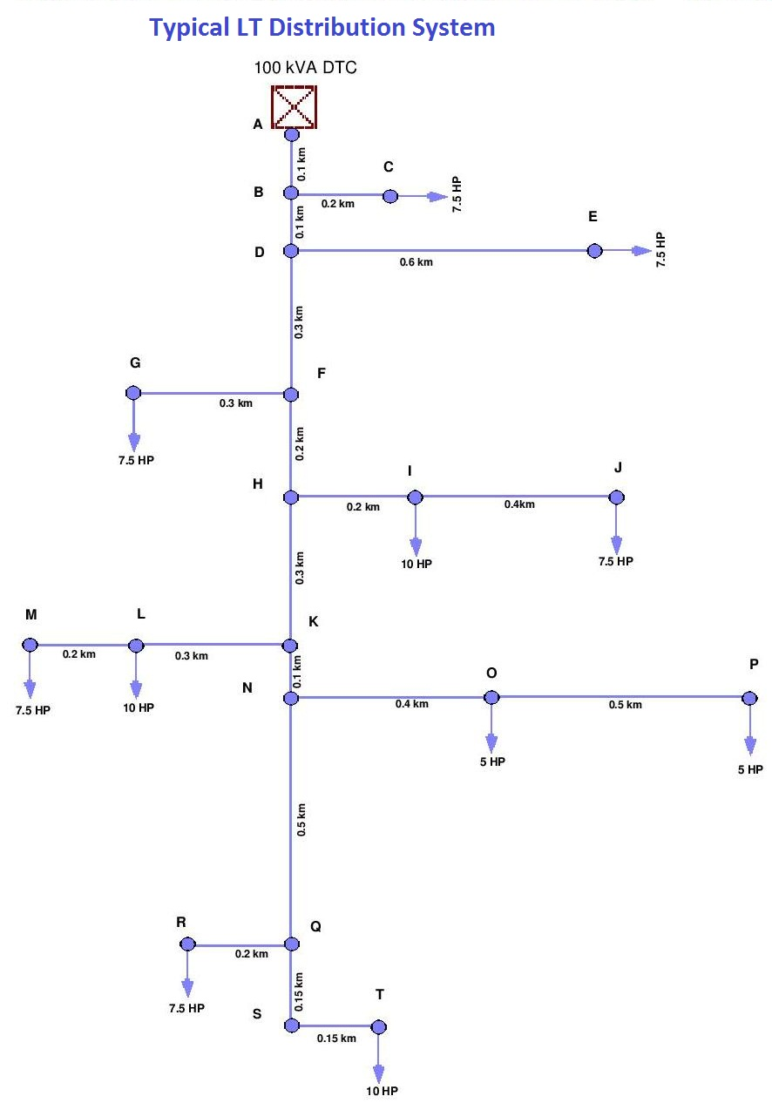

|  |  |  |  |  |  |  |  |  |  |
| --- | --- | --- | --- | --- | --- | --- | --- | --- | --- |
| **Peak Power Loss calculations by 3*I*I*R and Voltage drop by I*R (Rabbit ACSR)** | | | | | | | | | |
| Sl No | Section | Current per HP | Connected load in HP | Current in each Section Amps | Sectional Length in KM | Rabbit ACSR Conductor resistance Ω per KM | Section Resistance in Ω | Peak power losses in kW (3*I²*R)/ 1000 | Voltage (I.R ) Drop in Volts |
| 1 | T-Q | 1.53 | 10 | 15.29 | 0.3 | 0.5524 | 0.17 | 0.116 | 2.535 |
| 2 | R-Q | 1.53 | 7.5 | 11.47 | 0.2 | 0.5524 | 0.11 | 0.044 | 1.267 |
| 3 | Q-N | 1.53 | 17.5 | 26.76 | 0.5 | 0.5524 | 0.28 | 0.594 | 7.392 |
| 4 | P-O | 1.53 | 5 | 7.65 | 0.5 | 0.5524 | 0.28 | 0.048 | 2.112 |
| 5 | O-N | 1.53 | 10 | 15.29 | 0.4 | 0.5524 | 0.22 | 0.155 | 3.379 |
| 6 | N-K | 1.53 | 27.5 | 42.06 | 0.1 | 0.5524 | 0.06 | 0.293 | 2.323 |
| 7 | M-L | 1.53 | 7.5 | 11.47 | 0.2 | 0.5524 | 0.11 | 0.044 | 1.267 |
| 8 | L-K | 1.53 | 17.5 | 26.76 | 0.3 | 0.5524 | 0.17 | 0.356 | 4.435 |
| 9 | K-H | 1.53 | 45 | 68.82 | 0.3 | 0.5524 | 0.17 | 2.355 | 11.405 |
| 10 | J-I | 1.53 | 7.5 | 11.47 | 0.4 | 0.5524 | 0.22 | 0.087 | 2.535 |
| 11 | I-H | 1.53 | 17.5 | 26.76 | 0.2 | 0.5524 | 0.11 | 0.237 | 2.957 |
| 12 | H-F | 1.53 | 62.5 | 95.59 | 0.2 | 0.5524 | 0.11 | 3.028 | 10.561 |
| 13 | G-F | 1.53 | 7.5 | 11.47 | 0.3 | 0.5524 | 0.17 | 0.065 | 1.901 |
| 14 | F-D | 1.53 | 70 | 107.06 | 0.3 | 0.5524 | 0.17 | 5.698 | 17.742 |
| 15 | E-D | 1.53 | 7.5 | 11.47 | 0.6 | 0.5524 | 0.33 | 0.131 | 3.802 |
| 16 | D-B | 1.53 | 77.5 | 118.53 | 0.1 | 0.5524 | 0.06 | 2.328 | 6.548 |
| 17 | C-B | 1.53 | 7.5 | 11.47 | 0.2 | 0.5524 | 0.11 | 0.044 | 1.267 |
| 18 | B-A | 1.53 | 85 | 130.00 | 0.1 | 0.5524 | 0.06 | 2.801 | 7.181 |
| 19 | **Total** | |  |  |  |  |  | **18.425** | **90.6** |
| 20 | Total connected load in HP | | | | | | | 85 | |
| 21 | Peak load at DTC during the year in Amps | | | | | | | 130 | |
| 22 | Number of hours the DTC was in service during the year | | | | | | | 8760 | |
| 23 | Load Factor assumed | | | | | | | 0.4 | |
| 24 | Loss load factor (L.L.F) | | | 0.3*LF+0.7*LF ² | | | | 0.232 | |
| 25 | Power factor | | | | | | | 0.8 | |
| 26 | Phase current per H.P. of load | | | | | | | 1.53 | |
| 27 | Total Peak power loss in KW | | | | | | | 18.425 | |
| 22 | Annual energy in put to DTC MU = | | | | | | | 0.25 | |
| (1.732*400*130*0.8*8760*0.4) / | | | | | | |
| (1000000*1000) | | | | | | |
| 23 | Annual Energy Loss in MU = PPL *T*LLF /1000000 whereas "T" is number of hours of power supply to DTC during the year | | | | | | | 0.037 | |
| 24 | % Energy Loss | | | | | | | 14.83% | |
| 25 | Total voltage drop -Volts | | | | | | | 90.61 | |
| 26 | % Voltage Regulation | | | | | | | 22.65% | |

* 1. **L.T. distribution line 3-Ph, 4 –Wire from a 100 KVA DTC with Weasel ACSR conductor:**

|  |  |  |  |  |  |  |  |  |  |
| --- | --- | --- | --- | --- | --- | --- | --- | --- | --- |
| **Peak Power Loss calculations by 3*I*I*R and Voltage drop by I*R (Weasel ACSR)** | | | | | | | | | |
| Sl No | Section | Current per HP | Connected load in HP | Current in each Section Amps | Sectional Length in KM | Weasel ACSR Conductor resistance Ω per KM | Section Resistance in Ω | Peak power losses in kW (3*I²*R)/ 1000 | Voltage (I.R ) Drop in Volts |
| 1 | T-Q | 1.53 | 10 | 15.29 | 0.3 | 0.9291 | 0.28 | 0.196 | 4.263 |
| 2 | R-Q | 1.53 | 7.5 | 11.47 | 0.2 | 0.9291 | 0.19 | 0.073 | 2.131 |
| 3 | Q-N | 1.53 | 17.5 | 26.76 | 0.5 | 0.9291 | 0.46 | 0.998 | 12.434 |
| 4 | P-O | 1.53 | 5 | 7.65 | 0.5 | 0.9291 | 0.46 | 0.081 | 3.552 |
| 5 | O-N | 1.53 | 10 | 15.29 | 0.4 | 0.9291 | 0.37 | 0.261 | 5.684 |
| 6 | N-K | 1.53 | 27.5 | 42.06 | 0.1 | 0.9291 | 0.09 | 0.493 | 3.908 |
| 7 | M-L | 1.53 | 7.5 | 11.47 | 0.2 | 0.9291 | 0.19 | 0.073 | 2.131 |
| 8 | L-K | 1.53 | 17.5 | 26.76 | 0.3 | 0.9291 | 0.28 | 0.599 | 7.460 |
| 9 | K-H | 1.53 | 45 | 68.82 | 0.3 | 0.9291 | 0.28 | 3.961 | 19.183 |
| 10 | J-I | 1.53 | 7.5 | 11.47 | 0.4 | 0.9291 | 0.37 | 0.147 | 4.263 |
| 11 | I-H | 1.53 | 17.5 | 26.76 | 0.2 | 0.9291 | 0.19 | 0.399 | 4.973 |
| 12 | H-F | 1.53 | 62.5 | 95.59 | 0.2 | 0.9291 | 0.19 | 5.094 | 17.762 |
| 13 | G-F | 1.53 | 7.5 | 11.47 | 0.3 | 0.9291 | 0.28 | 0.110 | 3.197 |
| 14 | F-D | 1.53 | 70 | 107.06 | 0.3 | 0.9291 | 0.28 | 9.584 | 29.841 |
| 15 | E-D | 1.53 | 7.5 | 11.47 | 0.6 | 0.9291 | 0.56 | 0.220 | 6.394 |
| 16 | D-B | 1.53 | 77.5 | 118.53 | 0.1 | 0.9291 | 0.09 | 3.916 | 11.013 |
| 17 | C-B | 1.53 | 7.5 | 11.47 | 0.2 | 0.9291 | 0.19 | 0.073 | 2.131 |
| 18 | B-A | 1.53 | 85 | 130.00 | 0.1 | 0.9291 | 0.09 | 4.711 | 12.078 |
| 19 | **Total** | |  |  |  |  |  | **30.989** | **152.4** |
| 20 | Total connected load in HP | | | | | | | 85 | |
| 21 | Peak load at DTC during the year in Amps | | | | | | | 130 | |
| 22 | Number of hours the DTC was in service during the year | | | | | | | 8760 | |
| 23 | Load Factor assumed | | | | | | | 0.4 | |
| 24 | Loss load factor (L.L.F) | | | 0.3*LF+0.7*LF ² | | | | 0.232 | |
| 25 | Power factor | | | | | | | 0.8 | |
| 26 | Phase current per H.P. of load | | | | | | | 1.53 | |
| 27 | Total Peak power loss in KW | | | | | | | 30.989 | |
| 22 | Annual energy in put to DTC MU = | | | | | | | 0.25 | |
| (1.732*400*130*0.8*8760*0.4) / | | | | | | |
| (1000000*1000) | | | | | | |
| 23 | Annual Energy Loss in MU = PPL *T*LLF /1000000 whereas "T" is number of hours of power supply to DTC during the year | | | | | | | 0.063 | |
| 24 | % Energy Loss | | | | | | | 24.95% | |
| 25 | Total voltage drop -Volts | | | | | | | 152.40 | |
| 26 | % Voltage Regulation | | | | | | | 38.10% | |

***Annexure-K:***

1. **Energy Loss assessment of DTCs**

|  |  |  |  |  |  |  |  |  |  |  |  |  |  |
| --- | --- | --- | --- | --- | --- | --- | --- | --- | --- | --- | --- | --- | --- |
| **Energy loss assessment of DTCs - Both Copper and Iron losses** | | | | | | | | | | | | | |
| **Sl No** | **Particulars** | | | | | **Values / Details** | | | | | | | |
| 1 | Number of hrs the Transformer is charged during 12 month | | | | | 8760 | | | | | | | |
| 2 | Peak current in Amps | | | | | 40 | | | | | | | |
| 3 | Power factor | | | | | 0.8 | | | | | | | |
| 4 | Peak load in kW | | | | | 610 | | | | | | | |
| 5 | Peak load in kVA | | | | | 762 | | | | | | | |
| 6 | The energy input to feeder during year in kWh | | | | | 2136263 | | | | | | | |
| 7 | Load factor | | | | | 0.40 | | | | | | | |
| 8 | Loss Load factor | | | | | 0.232 | | | | | | | |
| 9 | DTCs loading | | | | | 0.76 | | | | | | | |
| **DTC Losses** | | | | | | | | | | | | | |
| **10** | **Capacity wise DTCs in kVA** | **Numbers** | **Total kVA** | **Rated Losses in watts** | | | **Number of hrs the DTCs were in service** | **Loading on DTCs** | **Iron losses** | | **Copper losses** | | **Total DTC losses** | | |
| **kWh** | **% Losses** | **kWh** | **% Losses** | **kWh** | | **% Losses** |
| Iron Losses | Copper losses | |
| a) | 16 | 0 | 0 | 80 | 475 | | 8760 | 0.76 | 0 | 0.00% | 0 | 0.00% | 0 | | 0.00% |
| b) | 25 | 0 | 0 | 100 | 685 | | 8760 | 0.76 | 0 | 0.00% | 0 | 0.00% | 0 | | 0.00% |
| c) | 63 | 0 | 0 | 180 | 1235 | | 8760 | 0.76 | 0 | 0.00% | 0 | 0.00% | 0 | | 0.00% |
| d) | **100** | **5** | **500** | **260** | **1760** | | **8760** | **0.76** | **11388** | **0.53%** | **10387** | **0.49%** | **21775** | | **1.02%** |
| e) | **250** | **2** | **500** | **620** | **3700** | | **8760** | **0.76** | **10862** | **0.51%** | **8734** | **0.41%** | **19597** | | **0.92%** |
| f) | 315 | 0 | 0 | 740 | 4200 | | 8760 | 0.76 | 0 | 0.00% | 0 | 0.00% | 0 | | 0.00% |
| g) | 500 | 0 | 0 | 1100 | 6500 | | 8760 | 0.76 | 0 | 0.00% | 0 | 0.00% | 0 | | 0.00% |
| h) | 750 | 0 | 0 | 1500 | 10000 | | 8760 | 0.76 | 0 | 0.00% | 0 | 0.00% | 0 | | 0.00% |
| **i)** | **Total** | **7** | **1000** |  | | |  |  | **22250** | **1.04%** | **19121** | **0.90%** | **41371** | | **1.94%** |

***Annexure-L:***

1. **Techno-Economical Analysis computation for a typical 11 kV feeder strengthening**

|  |  |  |  |  |  |  |  |  |  |  |  |  |  |  |  |  |  |  |  |  |  |  |  |  |  |  |  |  |  |  |  |  |  |  |  |  |  |  |  |  |  |  |  |  |  |  |  |  |  |  |  |  |  |  |  |  |  |  |  |  |  |  |  |  |  |  |  |  |  |  |  |  |  |  |  |  |  |  |  |  |  |  |  |  |  |  |  |  |  |  |  |  |  |  |  |  |  |  |  |  |  |  |  |  |  |  |  |  |  |  |  |  |  |  |  |  |  |  |  |  |
| --- | --- | --- | --- | --- | --- | --- | --- | --- | --- | --- | --- | --- | --- | --- | --- | --- | --- | --- | --- | --- | --- | --- | --- | --- | --- | --- | --- | --- | --- | --- | --- | --- | --- | --- | --- | --- | --- | --- | --- | --- | --- | --- | --- | --- | --- | --- | --- | --- | --- | --- | --- | --- | --- | --- | --- | --- | --- | --- | --- | --- | --- | --- | --- | --- | --- | --- | --- | --- | --- | --- | --- | --- | --- | --- | --- | --- | --- | --- | --- | --- | --- | --- | --- | --- | --- | --- | --- | --- | --- | --- | --- | --- | --- | --- | --- | --- | --- | --- | --- | --- | --- | --- | --- | --- | --- | --- | --- | --- | --- | --- | --- | --- | --- | --- | --- | --- | --- | --- | --- | --- |
| |  |  |  |  | | --- | --- | --- | --- | | **Techno-Economical Analysis by Present Worth Analysis/Discount Cash Flow method** | | | | | **Sl No** | **Particulars** |  | **Values** | | **1** | **11 kV Feeder details** |  |  | | a) | Name of the 11 kV feeder | Ghandhinagara | Kikkeri substation | | b) | Peak load during the year | 192 Amps /3.2 MW |  | | c) | Energy in put to the feeder during the year at substation | 11.5 MU |  | | d) | Number of I.P. sets in the feeder | 817 |  | | e) | Capital Cost per I.P. set for conversion to HVDS | Rs 0.356 Lakhs |  | |  |  |  |  | | **2** | **In Put Data as per actual** |  |  | | a) | Annual Interest Charges |  | **12.00%** | | b) | O and M Charges |  | **1.10%** | | c) | Project Life |  | **25 Years** | | d) | Annuity/ Discount Factor |  | **7.843** | | e) | Average Purchase rate of energy | Rs per kWh | **3.80** | |  |  |  |  | | **3** | **Capital Out go** |  |  | | a) | Capital investment in Rs Lakhs | As per estimate / awarded | **290.60** | | b) | Annual O&M Expenses at 1.1 % | Investment * (O&M charges/100) | 3.197 | | c) | Present Worth of Annual Expenses in Rs | Annual expenses * Annuity Factor | 25.07 | | **4** | **Present Worth of Cash Outflow in Rs** | **Investment + Present worth of annual expenses** | **315.67** | |  |  |  |  | | **5** | **Benefit** |  |  | | a) | Reduction of Annual Energy losses in **MU** | As computed | **1.74** | | b) | Cost of reduction of Annual Energy Losses in Rs Lakhs | Annual reduction of Energy losses in MU * Purchase rate of energy*10 (To Convert MU into Lakh units) | 66.12 | | **6** | **Present Worth of Annual Energy Losses in Rs Lakhs** | Cost of Annual Energy losses * annuity factor | **519** | |  |  |  |  | | **7** | **Benefit To Cost Ratio** | (Net Benefit)/Investment | **1.64** | | **8** | **Payback period in number of years** | Capital cost / Cost of reduction of annual Energy losses | **4.40** | | **9** | **Economical viability** |  | **Viable** | |
| 1. **Computation of Annuity / Discount factor:** |
| |  |  |  |  |  |  |  |  |  | | --- | --- | --- | --- | --- | --- | --- | --- | --- | | Discount Factor | | **[ ( 1 + i ) n ) -1 ] / [ ( i ( 1 + i ) n ) ]** | | | | | | | | **Life in years(n)** | 25 | 25 | 25 | 25 | 30 | 30 | 30 | 30 | | **Rate of Interest (i)** | 0.13 | 0.12 | 0.11 | 0.1 | 0.13 | 0.12 | 0.11 | 0.1 | | **Discount factor** | 7.33 | 7.843 | 8.42 | 9.077 | 7.496 | 8.055 | 8.694 | 9.427 | |
|  |
|  |